**Assignment 19.3:**

Create a dataframe with 1 to 100 and save as parquet file.

Load the number into variable.

Create RDD using the variable.

Create data frame using RDD.

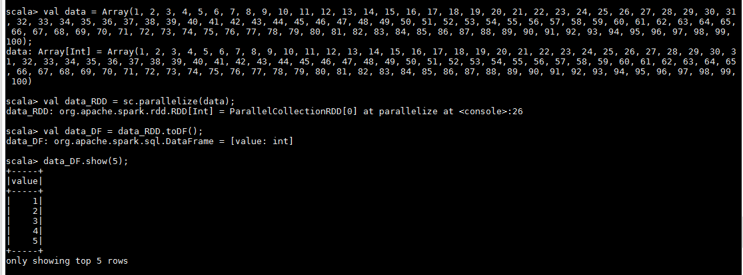

Storing dataframe as parquet file:-

Directory “parquet_file” was created at “/home/acadgild/manjunath”. Parquet files were created under directory “parquet_file”.



